Problem 0

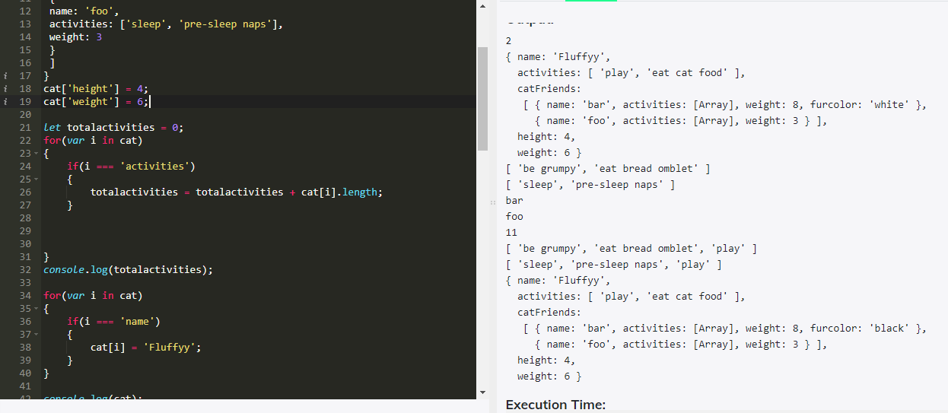

Problem 0

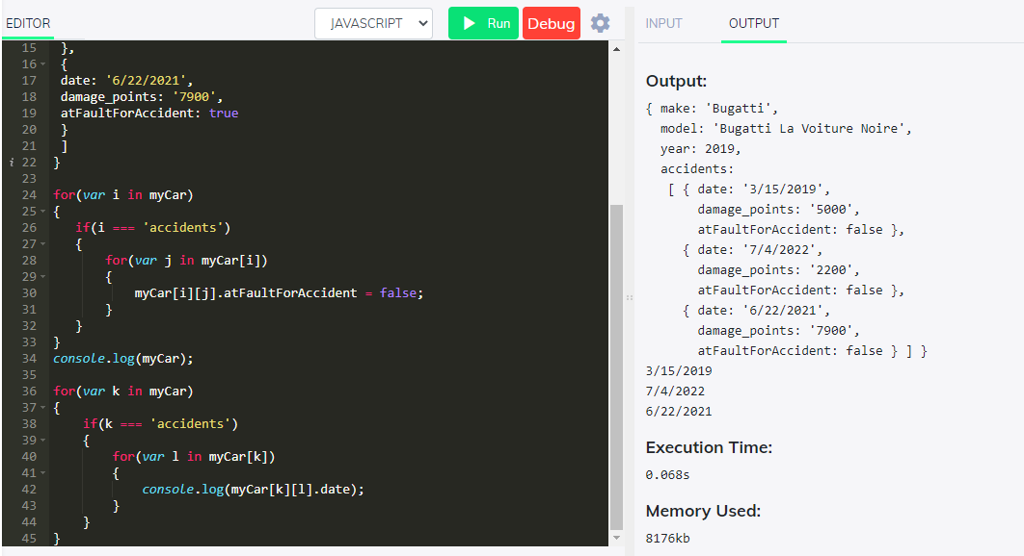

Problem 1:

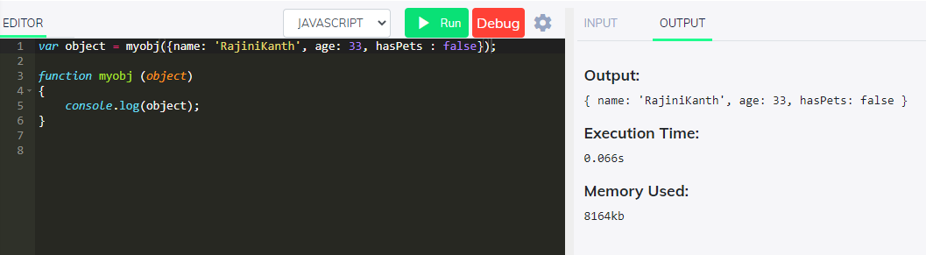

Problem 2

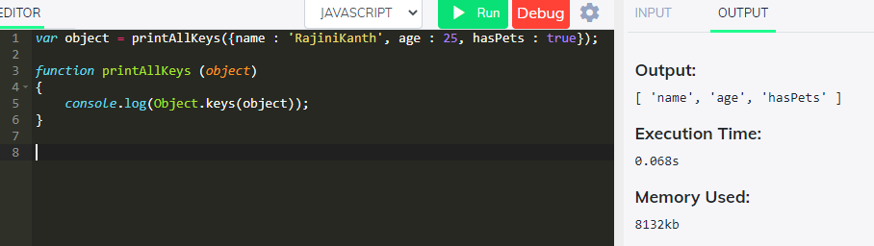

Problem 3

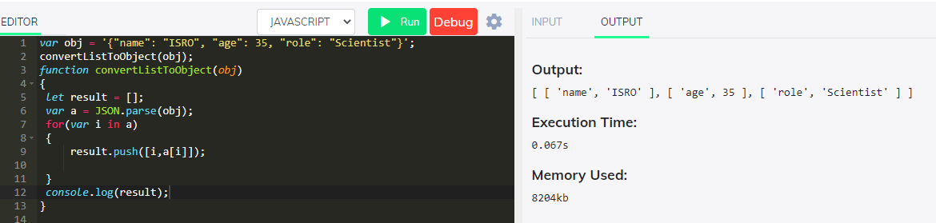

Problem 4

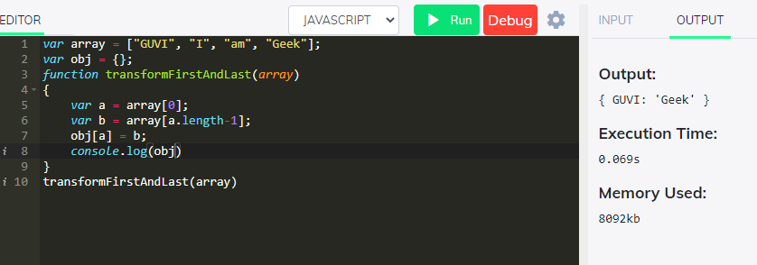

Problem 5

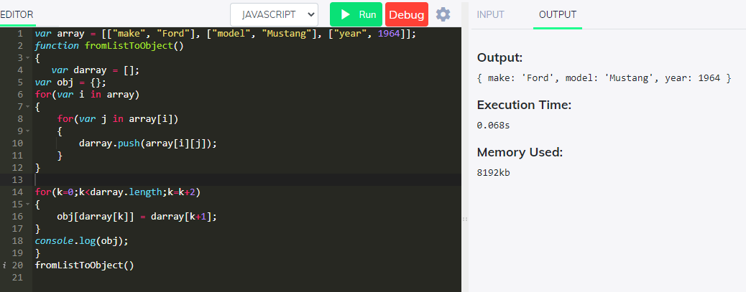

Problem 9

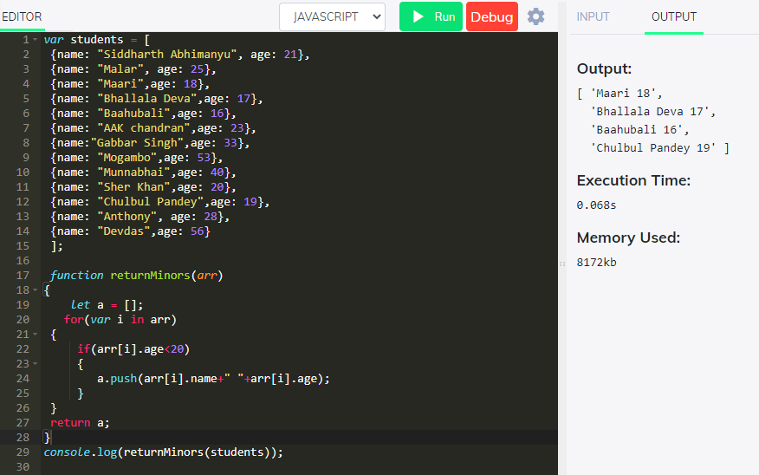

Problem 8

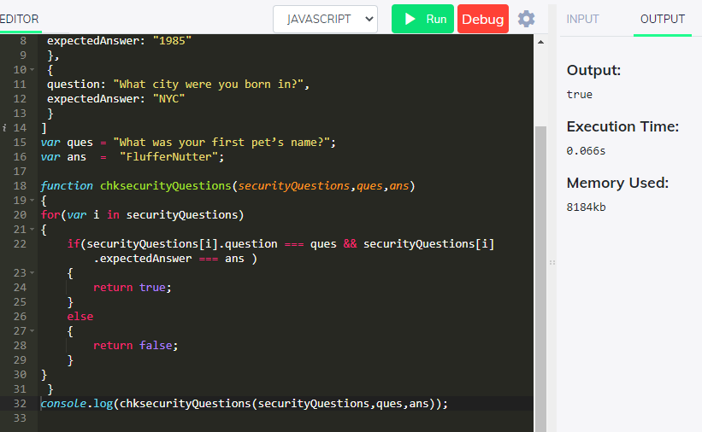

Problem 7

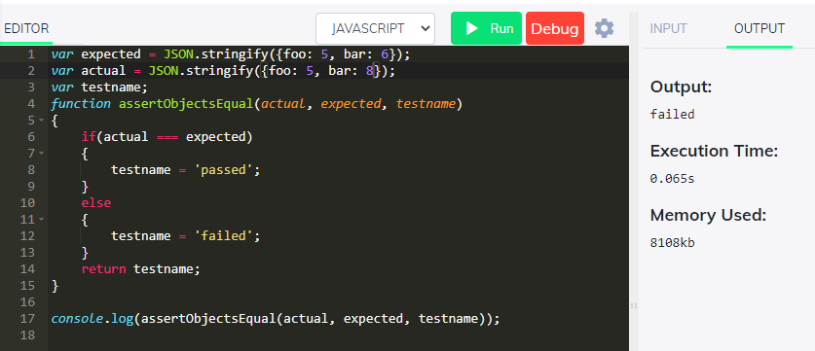

Problem 6

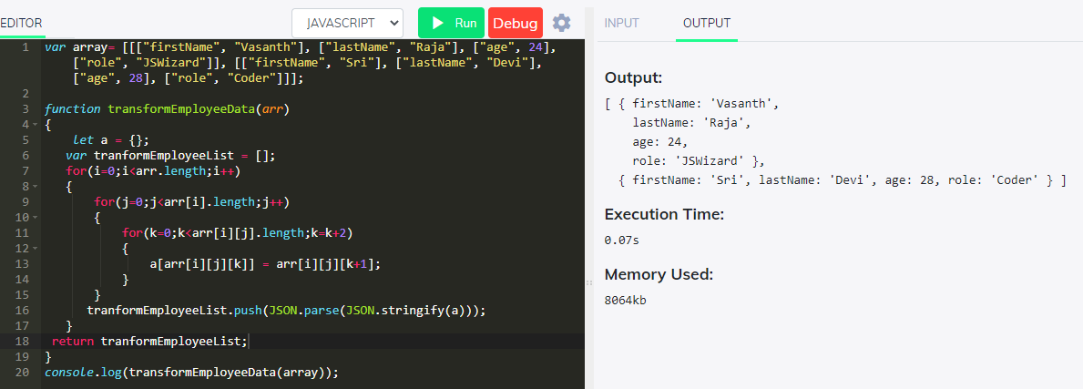

1. **What happens when an URL is entered?**

URL stands for Uniform resource locator.

<https://www.guvi.in/> - URL

First part of URL specifies https specifies which type of protocol browser should use for communication. There are different types of protocols http, https, ftp.

http - Hyper Text Transfer protocol. It is unsecure and send data over port 80

https - Hyper Text Transfer protocol. It is unsecure and send data over port 443

ftp – file transfer protocol used to share files across the system.

DNS – Domain Name System – Maintains all the address of websites.

Every url in the internet has unique ip address of the computer which is hosting the server of that website. DNS maps the ip address of the host to url.

When an url is entered DNS initiates a query to find the ip address of the host server. The information is sent in terms of small data packets.

Web browser initiates a TCP protocol to establish a connection between web browser and host server. Web browser send http request to web server (GET or POST). Web server handles the request and send response in JSON or XML or HTML format. Once the response is received in html format web page will be displayed at client end.

1. **Difference between Browser JS and Node JS**

Browser JS

1. Browser js is used for client-side scripting on web pages.
2. JavaScript code will be run in browser console.
3. JavaScript is used in front end development.
4. JavaScript code can run on different browser engines.
5. JavaScript will be able to add html tags and play with dom.

Node JS

1. Node js is run time environment which is used to run JavaScript code and used for server-side scripting.
2. JavaScript code will be run outside the browser.
3. Node JS is used in server-side development.
4. Nodejs code run only in v8 engine of google chrome.
5. Node js doesn’t have capability to add html tags.
6. **Difference between Copy by Value and Copy by reference**

Copy by Value

Also called as deep copy. Copy by value works for all the primitive data types such as integers, strings, null, Boolean etc. In this the original value when copied to another and the changes made on later will not affect the original value as they are pointed to different address in the memory.

Copy by Reference

Also called as Shallow copy. This works for composite data types such as Arrays and objects. In this the original value when copied to another and the changes made on later will affect the original value as they both are pointed to same address in the memory.

1. **How Copy by Value is achieved for Composite data types Arrays and Objects**

Array.from() method copies the original array into another array and changes made on the later will not affect the original array. With this copy by value is achieved for Arrays.

let a = [1,2,3,4];

let b = Array.from(a);

b[0] = 10;

console.log(b) ->b = [10,2,3,4]

console.log(a) ->a = [1,2,3,4]

For object JSON.parse() and JSON.stringify() methods will be helpful to achieve Copy by value instead of copy by reference.

let a = [{x:1,y:2,z:3}];

let b = Array.from(JSON.parse(JSON.stringify(a)));

b[0].x = 0;

console.log(JSON.stringify(a));

console.log(JSON.stringify(b));

Output:

[{"x":1,"y":2,"z":3}]

[{"x":0,"y":2,"z":3}]

1. **Differences between HTTP1.1 and HTTP2**

Web browsers only support http/2 through encrypted connections increasing user and application security.

http/2 user header compression mechanism to reduce overhead caused by TCP slow start.

http/2 request displays browser content quickly compared to http/1.1

http/2 can initiate multiple requests in parallel compared to http/1.1